Introduction
Robotics and automation have become important technologies for developing intelligent systems capable of performing tasks with minimal human intervention. Mobile robots are widely used in areas such as surveillance, industrial automation, transportation, education, and hazardous-environment applications. A smart mobile robot should be capable of operating autonomously while also providing an option for human control whenever required.
The “Smart Autonomous Multi-Mode Robot Using Arduino” is designed to provide multiple methods of controlling a mobile robotic vehicle using an Arduino Uno as the main controller. The robot consists of four BO DC motors driven by an L298N motor driver, along with a Bluetooth communication module, ultrasonic sensor, servo motor, and three mode-selection push buttons. The Arduino processes the sensor information and user commands to control the movement of the robot.
The proposed system provides three different operating modes. In the first mode, Obstacle Avoidance Mode, the robot operates autonomously by detecting obstacles using an ultrasonic sensor. When an obstacle is detected, the robot stops, scans the surrounding area using a servo-mounted ultrasonic sensor, and selects a suitable direction to continue its movement. This allows the robot to navigate without continuous human intervention.
In the second mode, Command Control Mode, the robot can be controlled remotely through Bluetooth using predefined commands such as forward, backward, left, right, and stop. In the third mode, Voice Control Mode, the user can provide voice commands through a mobile device, which are transmitted to the robot through the Bluetooth module. The Arduino interprets these commands and controls the motors accordingly.
The three push buttons provide a simple interface for selecting the required operating mode. This multi-mode approach makes the robot flexible by combining autonomous navigation, wireless manual control, and voice-based control in a single system. The prototype demonstrates how a low-cost Arduino-based embedded system can be used to develop a versatile and intelligent robotic platform for educational, experimental, and basic automation applications.

Literature Survey
The development of autonomous and remotely controlled mobile robots has attracted significant attention in the fields of robotics, embedded systems, automation, and the Internet of Things. Researchers have developed different approaches for controlling mobile robots using microcontrollers, sensors, wireless communication, and artificial intelligence. The major research areas related to the proposed Smart Autonomous Multi-Mode Robot Using Arduino are discussed below.

1. Arduino-Based Mobile Robots
Arduino-based controllers are widely used in educational and prototype robotic applications because of their simple programming environment, low cost, and availability of different input/output interfaces. Arduino Uno can interface with motor drivers, sensors, Bluetooth modules, and other peripheral devices. Several robotic platforms use Arduino to control DC motors and implement basic navigation algorithms. These systems demonstrate that Arduino is suitable for developing low-cost mobile robots and experimental automation platforms.

2. Obstacle Avoidance Robots
Obstacle avoidance is one of the fundamental capabilities of autonomous mobile robots. Many existing systems use ultrasonic sensors to measure the distance between the robot and nearby objects. When an obstacle is detected within a predefined distance, the controller changes the direction of the motors to avoid collision. Some systems use a servo motor to rotate the ultrasonic sensor and scan different directions before selecting a suitable path. This approach provides a simple and economical method for autonomous navigation.

3. Motor Control Using L298N
DC motors require a suitable driver circuit because the current supplied directly by a microcontroller is insufficient to operate them. The L298N dual H-bridge motor driver is commonly used in small robotic vehicles to control the direction of DC motors. By controlling the input signals of the H-bridge, the robot can perform forward, backward, left, right, and stop operations. For four-wheel robots, two motors can typically be connected to each channel, with the motors on each side operating together.

4. Bluetooth-Based Robot Control
Bluetooth communication is commonly used for short-range wireless control of robotic vehicles. A Bluetooth module such as the HC-05 can communicate with an Arduino through serial communication. Commands received from a smartphone application can be interpreted by the microcontroller to control the movement of the robot. Bluetooth-based systems eliminate the need for wired control and provide convenient remote operation within the communication range.

5. Voice-Controlled Robots
Voice control has been explored as an alternative human-machine interaction method for mobile robots. In such systems, voice commands are processed by a smartphone or voice-recognition application and transmitted to the robot through a wireless communication module. Commands such as forward, backward, left, right, and stop can then be converted into corresponding motor-control signals. Voice control improves the ease of operation and demonstrates the integration of human-machine interaction with embedded robotic systems.

6. Multi-Mode Robotic Systems
Traditional robotic vehicles often focus on a single operating method, such as manual Bluetooth control or autonomous obstacle avoidance. More advanced systems combine multiple control methods to increase operational flexibility. A multi-mode robot can provide autonomous operation when human intervention is not required and switch to manual or voice control when direct user control is preferred. Mode-selection switches provide a simple and reliable way to select the required operating method.

7. Research Gap
From the existing approaches, it can be observed that Arduino-based obstacle avoidance, Bluetooth control, and voice-controlled robots are individually well established. However, many basic prototype systems implement these features separately rather than integrating them into a single platform with dedicated mode selection.
The proposed project combines these concepts into one robotic platform by providing:
- Obstacle Avoidance Mode for autonomous navigation.
- Command Control Mode for Bluetooth-based manual operation.
- Voice Control Mode for voice-based operation.
- Three push buttons for simple mode selection.
- Ultrasonic sensor with servo scanning for improved obstacle detection.
- L298N motor driver for controlling four BO DC motors.
Thus, the proposed system focuses on integrating different robot-control techniques into a single, low-cost Arduino-based platform that can be used for robotics education, demonstrations, and prototype development.

Existing System
In existing robotic vehicle systems, different control techniques are generally implemented separately depending on the intended application. Common approaches include manual control using Bluetooth or remote controllers, voice-based control, and autonomous obstacle avoidance. These systems are mainly developed using microcontrollers such as Arduino and motor driver circuits for controlling DC motors.
In a conventional manual Bluetooth-controlled robot, the user operates the robot through a smartphone application. Commands such as forward, backward, left, right, and stop are transmitted through a Bluetooth module to the microcontroller. The Arduino processes the received commands and controls the motors through a motor driver. However, the robot depends completely on the user and cannot independently avoid obstacles.
In an obstacle avoidance robot, ultrasonic sensors are used to detect objects in front of the robot. When an obstacle is detected, the controller stops the motors and changes the direction of movement. Some systems use a servo motor to rotate the ultrasonic sensor and check different directions. Although this provides autonomous movement, the user has limited direct control over the robot.
Another approach is the voice-controlled robot, where the user provides movement instructions through a smartphone-based voice recognition application. The recognized command is transmitted wirelessly to the robot, which performs the corresponding movement. This method provides convenient operation but still requires the user to continuously provide commands.

Limitations of Existing Systems
The major limitations of conventional systems are:
- Single-mode operation – many systems support only one control method.
- Dependence on the user – manually controlled robots cannot navigate independently.
- Limited flexibility – changing between autonomous and manual control may require hardware or software modifications.
- Collision risk – manual-control robots may collide with obstacles if the operator does not detect them in time.
- Separate implementations – Bluetooth, voice, and obstacle-avoidance functions are often developed as independent systems.
- Limited user interaction – conventional autonomous robots may not provide convenient manual or voice control when required.
The proposed Smart Autonomous Multi-Mode Robot Using Arduino addresses these limitations by integrating obstacle avoidance, Bluetooth command control, and voice control into a single robotic platform. Three dedicated push buttons allow the user to select the required operating mode according to the application.

Proposed System
The proposed Smart Autonomous Multi-Mode Robot Using Arduino is designed as a flexible robotic vehicle that combines autonomous obstacle avoidance, Bluetooth command control, and voice control in a single system. The main objective of the proposed system is to provide multiple operating modes so that the robot can be used either independently or under user control.
The system uses an Arduino Uno as the central controller. Four BO DC motors are used to provide movement, while an L298N motor driver is used to control the direction of the motors. An HC-SR04 ultrasonic sensor is used to detect obstacles, and the sensor is mounted on a servo motor so that the robot can scan different directions. A Bluetooth module provides wireless communication between the robot and a smartphone.
Three push buttons are provided for selecting the operating mode:
- Button 1 – Obstacle Avoidance Mode: The robot operates autonomously. The ultrasonic sensor continuously measures the distance from obstacles. If an obstacle is detected, the robot stops, scans the available directions, and moves toward a suitable open path.
- Button 2 – Command Control Mode: The robot receives movement commands through Bluetooth from a mobile application. Commands such as forward, backward, left, right, and stop are used to control the robot.
- Button 3 – Voice Control Mode: The user provides voice commands through a smartphone. The recognized commands are transmitted through Bluetooth to the Arduino, which converts them into appropriate motor-control actions.

Working Principle
When the robot is powered ON, the Arduino initializes the sensors, motor driver, servo, Bluetooth communication, and three mode-selection buttons. The user selects one of the three operating modes using the corresponding push button.
In Obstacle Avoidance Mode, the Arduino continuously reads the ultrasonic sensor. When the measured distance is safe, the robot moves forward. If an obstacle is detected within the predefined distance, the robot stops and uses the servo-mounted sensor to check the left and right directions. Based on the measured distances, the Arduino selects a suitable direction and commands the motors through the L298N driver.
In Command Control Mode, commands received through Bluetooth are processed by the Arduino. The corresponding motor-control signals are generated to move the robot in the requested direction.
In Voice Control Mode, voice instructions from the user are converted into commands by the smartphone application and transmitted through Bluetooth. The Arduino receives and interprets these commands and controls the robot accordingly.

Major Features of the Proposed System
- Three operating modes in one robotic platform.
- Autonomous obstacle detection and avoidance using an ultrasonic sensor.
- Servo-based scanning of different directions.
- Bluetooth wireless control using a smartphone.
- Voice-based robot operation through Bluetooth.
- Three dedicated push buttons for easy mode selection.
- Four BO motors for four-wheel movement.
- L298N motor driver for motor direction control.
- Arduino Uno provides centralized control of all system operations.
- Low-cost and simple hardware architecture, making the system suitable for educational and prototype applications.
Overall, the proposed system integrates autonomous navigation and multiple forms of human control into a single Arduino-based robotic vehicle. This provides greater operational flexibility compared with conventional robots that use only one control method.

EMBEDDED SYSTEMS
2.1 Embedded Systems:
An embedded system is a computer system designed to perform one or a few dedicated functions often with real-time computing constraints. It is embedded as part of a complete device often including hardware and mechanical parts. By contrast, a general-purpose computer, such as a personal computer (PC), is designed to be flexible and to meet a wide range of end-user needs. Embedded systems control many devices in common use today.
Embedded systems are controlled by one or more main processing cores that are typically either microcontrollers or digital signal processors (DSP). The key characteristic, however, is being dedicated to handle a particular task, which may require very powerful processors. For example, air traffic control systems may usefully be viewed as embedded, even though they involve mainframe computers and dedicated regional and national networks between airports and radar sites. (Each radar probably includes one or more embedded systems of its own.)
Since the embedded system is dedicated to specific tasks, design engineers can optimize it to reduce the size and cost of the product and increase the reliability and performance. Some embedded systems are mass-produced, benefiting from economies of scale.
Physically embedded systems range from portable devices such as digital watches and MP3 players, to large stationary installations like traffic lights, factory controllers, or the systems controlling nuclear power plants. Complexity varies from low, with a single microcontroller chip, to very high with multiple units, peripherals and networks mounted inside a large chassis or enclosure.
In general, "embedded system" is not a strictly definable term, as most systems have some element of extensibility or programmability. For example, handheld computers share some elements with embedded systems such as the operating systems and microprocessors which power them, but they allow different applications to be loaded and peripherals to be connected. Moreover, even systems which don't expose programmability as a primary feature generally need to support software updates. On a continuum from "general purpose" to "embedded", large application systems will have subcomponents at most points even if the system as a whole is "designed to perform one or a few dedicated functions", and is thus appropriate to call "embedded". A modern example of embedded system is shown in fig: 2.1.
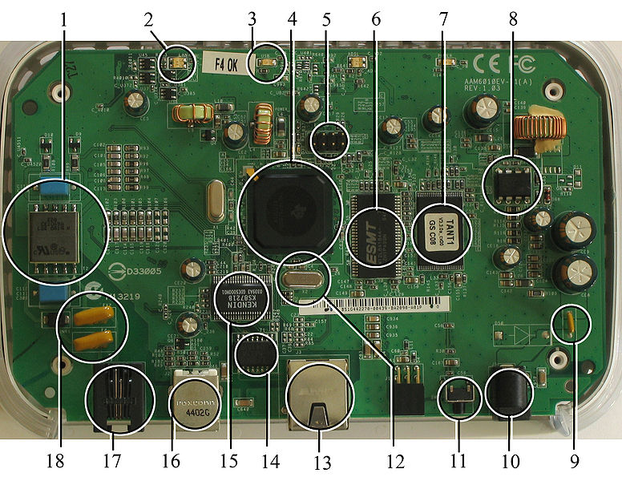
Fig 2.1:A modern example of embedded system
Labeled parts include microprocessor (4), RAM (6), flash memory (7).Embedded systems programming is not like normal PC programming. In many ways, programming for an embedded system is like programming PC 15 years ago. The hardware for the system is usually chosen to make the device as cheap as possible. Spending an extra dollar a unit in order to make things easier to program can cost millions. Hiring a programmer for an extra month is cheap in comparison. This means the programmer must make do with slow processors and low memory, while at the same time battling a need for efficiency not seen in most PC applications. Below is a list of issues specific to the embedded field.
2.1.1 History:
In the earliest years of computers in the 1930–40s, computers were sometimes dedicated to a single task, but were far too large and expensive for most kinds of tasks performed by embedded computers of today. Over time however, the concept of programmable controllers evolved from traditional electromechanical sequencers, via solid state devices, to the use of computer technology.
One of the first recognizably modern embedded systems was the Apollo Guidance Computer, developed by Charles Stark Draper at the MIT Instrumentation Laboratory. At the project's inception, the Apollo guidance computer was considered the riskiest item in the Apollo project as it employed the then newly developed monolithic integrated circuits to reduce the size and weight. An early mass-produced embedded system was the Autonetics D-17 guidance computer for the Minuteman missile, released in 1961. It was built from transistor logic and had a hard disk for main memory. When the Minuteman II went into production in 1966, the D-17 was replaced with a new computer that was the first high-volume use of integrated circuits.
2.1.2 Tools:
Embedded development makes up a small fraction of total programming. There's also a large number of embedded architectures, unlike the PC world where 1 instruction set rules, and the UNIX world where there's only 3 or 4 major ones. This means that the tools are more expensive. It also means that they're lowering featured, and less developed. On a major embedded project, at some point you will almost always find a compiler bug of some sort.

Debugging tools are another issue. Since you can't always run general programs on your embedded processor, you can't always run a debugger on it. This makes fixing your program difficult. Special hardware such as JTAG ports can overcome this issue in part. However, if you stop on a breakpoint when your system is controlling real world hardware (such as a motor), permanent equipment damage can occur. As a result, people doing embedded programming quickly become masters at using serial IO channels and error message style debugging.

2.1.3 Resources:
To save costs, embedded systems frequently have the cheapest processors that can do the job. This means your programs need to be written as efficiently as possible. When dealing with large data sets, issues like memory cache misses that never matter in PC programming can hurt you. Luckily, this won't happen too often- use reasonably efficient algorithms to start, and optimize only when necessary. Of course, normal profilers won't work well, due to the same reason debuggers don't work well.
Memory is also an issue. For the same cost savings reasons, embedded systems usually have the least memory they can get away with. That means their algorithms must be memory efficient (unlike in PC programs, you will frequently sacrifice processor time for memory, rather than the reverse). It also means you can't afford to leak memory. Embedded applications generally use deterministic memory techniques and avoid the default "new" and "malloc" functions, so that leaks can be found and eliminated more easily. Other resources programmers expect may not even exist. For example, most embedded processors do not have hardware FPUs (Floating-Point Processing Unit). These resources either need to be emulated in software, or avoided altogether.

2.1.4 Real Time Issues:
Embedded systems frequently control hardware, and must be able to respond to them in real time. Failure to do so could cause inaccuracy in measurements, or even damage hardware such as motors. This is made even more difficult by the lack of resources available. Almost all embedded systems need to be able to prioritize some tasks over others, and to be able to put off/skip low priority tasks such as UI in favor of high priority tasks like hardware control.
2.2 Need For Embedded Systems:
The uses of embedded systems are virtually limitless, because every day new products are introduced to the market that utilizes embedded computers in novel ways. In recent years, hardware such as microprocessors, microcontrollers, and FPGA chips have become much cheaper. So when implementing a new form of control, it's wiser to just buy the generic chip and write your own custom software for it. Producing a custom-made chip to handle a particular task or set of tasks costs far more time and money. Many embedded computers even come with extensive libraries, so that "writing your own software" becomes a very trivial task indeed. From an implementation viewpoint, there is a major difference between a computer and an embedded system. Embedded systems are often required to provide Real-Time response. The main elements that make embedded systems unique are its reliability and ease in debugging.

2.2.1 Debugging:
Embedded debugging may be performed at different levels, depending on the facilities available. From simplest to most sophisticate they can be roughly grouped into the following areas:
- Interactive resident debugging, using the simple shell provided by the embedded operating system (e.g. Forth and Basic)
- External debugging using logging or serial port output to trace operation using either a monitor in flash or using a debug server like the Remedy Debugger which even works for heterogeneous multi core systems.
- An in-circuit debugger (ICD), a hardware device that connects to the microprocessor via a JTAG or Nexus interface. This allows the operation of the microprocessor to be controlled externally, but is typically restricted to specific debugging capabilities in the processor.
- An in-circuit emulator replaces the microprocessor with a simulated equivalent, providing full control over all aspects of the microprocessor.
- A complete emulator provides a simulation of all aspects of the hardware, allowing all of it to be controlled and modified and allowing debugging on a normal PC.
- Unless restricted to external debugging, the programmer can typically load and run software through the tools, view the code running in the processor, and start or stop its operation. The view of the code may be as assembly code or source-code.

Because an embedded system is often composed of a wide variety of elements, the debugging strategy may vary. For instance, debugging a software(and microprocessor) centric embedded system is different from debugging an embedded system where most of the processing is performed by peripherals (DSP, FPGA, co-processor). An increasing number of embedded systems today use more than one single processor core. A common problem with multi-core development is the proper synchronization of software execution. In such a case, the embedded system design may wish to check the data traffic on the busses between the processor cores, which requires very low-level debugging, at signal/bus level, with a logic analyzer, for instance.

2.2.2 Reliability:
Embedded systems often reside in machines that are expected to run continuously for years without errors and in some cases recover by them if an error occurs. Therefore the software is usually developed and tested more carefully than that for personal computers, and unreliable mechanical moving parts such as disk drives, switches or buttons are avoided.
Specific reliability issues may include:
- The system cannot safely be shut down for repair, or it is too inaccessible to repair. Examples include space systems, undersea cables, navigational beacons, bore-hole systems, and automobiles.
- The system must be kept running for safety reasons. "Limp modes" are less tolerable. Often backup s are selected by an operator. Examples include aircraft navigation, reactor control systems, safety-critical chemical factory controls, train signals, engines on single-engine aircraft.
- The system will lose large amounts of money when shut down: Telephone switches, factory controls, bridge and elevator controls, funds transfer and market making, automated sales and service.

A variety of techniques are used, sometimes in combination, to recover from errors—both software bugs such as memory leaks, and also soft errors in the hardware:
- Watchdog timer that resets the computer unless the software periodically notifies the watchdog
- Subsystems with redundant spares that can be switched over to
- software "limp modes" that provide partial function
- Designing with a Trusted Computing Base (TCB) architecture[6] ensures a highly secure & reliable system environment
- An Embedded Hypervisor is able to provide secure encapsulation for any subsystem component, so that a compromised software component cannot interfere with other subsystems, or privileged-level system software. This encapsulation keeps faults from propagating from one subsystem to another, improving reliability. This may also allow a subsystem to be automatically shut down and restarted on fault detection.
- Immunity Aware Programming

2.3 Explanation of Embedded Systems:
2.3.1 Software Architecture:
There are several different types of software architecture in common use.
- Simple Control Loop:
In this design, the software simply has a loop. The loop calls subroutines, each of which manages a part of the hardware or software.
- Interrupt Controlled System:
Some embedded systems are predominantly interrupt controlled. This means that tasks performed by the system are triggered by different kinds of events. An interrupt could be generated for example by a timer in a predefined frequency, or by a serial port controller receiving a byte. These kinds of systems are used if event handlers need low latency and the event handlers are short and simple.
Usually these kinds of systems run a simple task in a main loop also, but this task is not very sensitive to unexpected delays. Sometimes the interrupt handler will add longer tasks to a queue structure. Later, after the interrupt handler has finished, these tasks are executed by the main loop. This method brings the system close to a multitasking kernel with discrete processes.
- Cooperative Multitasking:
A non-preemptive multitasking system is very similar to the simple control loop scheme, except that the loop is hidden in an API. The programmer defines a series of tasks, and each task gets its own environment to “run” in. When a task is idle, it calls an idle routine, usually called “pause”, “wait”, “yield”, “nop” (stands for no operation), etc.The advantages and disadvantages are very similar to the control loop, except that adding new software is easier, by simply writing a new task, or adding to the queue-interpreter.
- Primitive Multitasking:
In this type of system, a low-level piece of code switches between tasks or threads based on a timer (connected to an interrupt). This is the level at which the system is generally considered to have an "operating system" kernel. Depending on how much functionality is required, it introduces more or less of the complexities of managing multiple tasks running conceptually in parallel.
As any code can potentially damage the data of another task (except in larger systems using an MMU) programs must be carefully designed and tested, and access to shared data must be controlled by some synchronization strategy, such as message queues, semaphores or a non-blocking synchronization scheme.
Because of these complexities, it is common for organizations to buy a real-time operating system, allowing the application programmers to concentrate on device functionality rather than operating system services, at least for large systems; smaller systems often cannot afford the overhead associated with a generic real time system, due to limitations regarding memory size, performance, and/or battery life.
- Microkernels And Exokernels:
A microkernel is a logical step up from a real-time OS. The usual arrangement is that the operating system kernel allocates memory and switches the CPU to different threads of execution. User mode processes implement major functions such as file systems, network interfaces, etc.
In general, microkernels succeed when the task switching and intertask communication is fast, and fail when they are slow. Exokernels communicate efficiently by normal subroutine calls. The hardware and all the software in the system are available to, and extensible by application programmers. Based on performance, functionality, requirement the embedded systems are divided into three categories:
2.3.2 Stand Alone Embedded System:
These systems takes the input in the form of electrical signals from transducers or commands from human beings such as pressing of a button etc.., process them and produces desired output. This entire process of taking input, processing it and giving output is done in standalone mode. Such embedded systems comes under stand alone embedded systems
Eg: microwave oven, air conditioner etc..
2.3.3 Real-time embedded systems:
Embedded systems which are used to perform a specific task or operation in a specific time period those systems are called as real-time embedded systems. There are two types of real-time embedded systems.
- Hard Real-time embedded systems:
These embedded systems follow an absolute dead line time period i.e.., if the tasking is not done in a particular time period then there is a cause of damage to the entire equipment.
Eg: consider a system in which we have to open a valve within 30 milliseconds. If this valve is not opened in 30 ms this may cause damage to the entire equipment. So in such cases we use embedded systems for doing automatic operations.
- Soft Real Time embedded systems:
Eg: Consider a TV remote control system, if the remote control takes a few milliseconds delay it will not cause damage either to the TV or to the remote control. These systems which will not cause damage when they are not operated at considerable time period those systems comes under soft real-time embedded systems.
2.3.4 Network communication embedded systems:
A wide range network interfacing communication is provided by using embedded systems.
Eg:
- Consider a web camera that is connected to the computer with internet can be used to spread communication like sending pictures, images, videos etc.., to another computer with internet connection throughout anywhere in the world.
- Consider a web camera that is connected at the door lock.
Whenever a person comes near the door, it captures the image of a person and sends to the desktop of your computer which is connected to internet. This gives an alerting message with image on to the desktop of your computer, and then you can open the door lock just by clicking the mouse. Fig: 2.2 show the network communications in embedded systems.
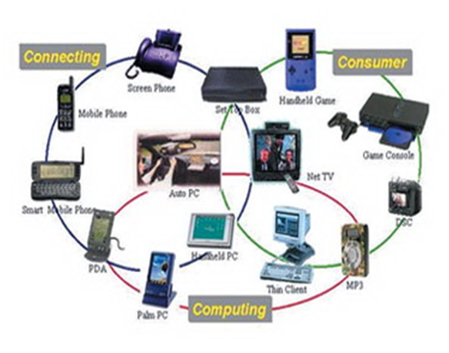
Fig 2.2: Network communication embedded systems

2.3.5 Different types of processing units:
The central processing unit (c.p.u) can be any one of the following microprocessor, microcontroller, digital signal processing.
- Among these Microcontroller is of low cost processor and one of the main advantage of microcontrollers is, the components such as memory, serial communication interfaces, analog to digital converters etc.., all these are built on a single chip. The numbers of external components that are connected to it are very less according to the application.
- Microprocessors are more powerful than microcontrollers. They are used in major applications with a number of tasking requirements. But the microprocessor requires many external components like memory, serial communication, hard disk, input output ports etc.., so the power consumption is also very high when compared to microcontrollers.
- Digital signal processing is used mainly for the applications that particularly involved with processing of signals
2.4 APPLICATIONS OF EMBEDDED SYSTEMS:
2.4.1 Consumer applications:
At home we use a number of embedded systems which include microwave oven, remote control, vcd players, dvd players, camera etc….
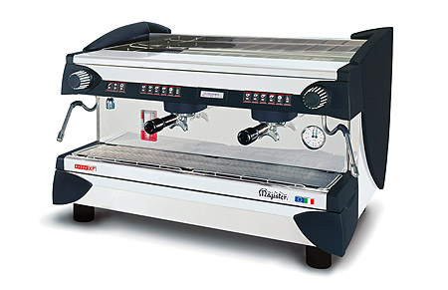
Fig2.3: Automatic coffee makes equipment
2.4.2 Office automation:
We use systems like fax machine, modem, printer etc…
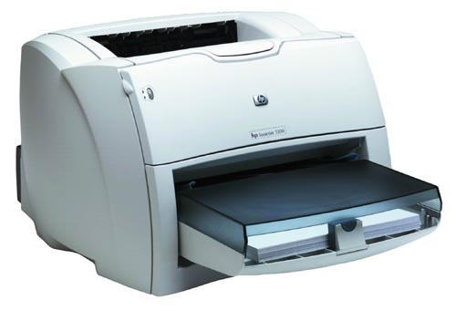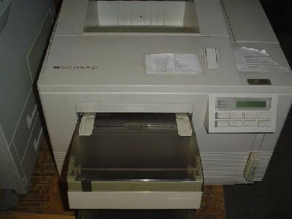
Fig2.4: Fax machine Fig2.5: Printing machine
2.4.3. Industrial automation:
Today a lot of industries are using embedded systems for process control. In industries we design the embedded systems to perform a specific operation like monitoring temperature, pressure, humidity ,voltage, current etc.., and basing on these monitored levels we do control other devices, we can send information to a centralized monitoring station.
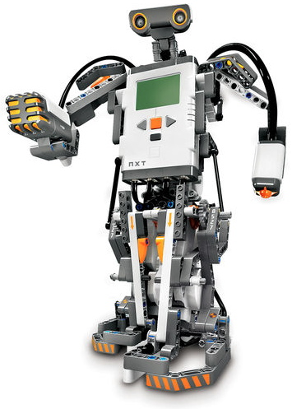
Fig2.6: Robot
In critical industries where human presence is avoided there we can use robots which are programmed to do a specific operation.
2.4.5 Computer networking:
Embedded systems are used as bridges routers etc..
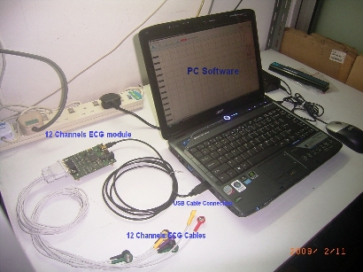
Fig2.7: Computer networking
2.4.6 Tele communications:
Cell phones, web cameras etc.
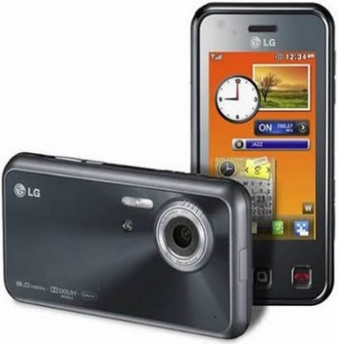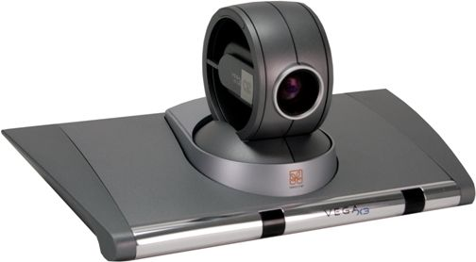
Fig2.8: Cell Phone Fig2.9: Web camera

HARDWARE DESCRIPTION

ARDUINO (UNO)

What is Arduino UNO?
Arduino UNO is a low-cost, flexible, and easy-to-use programmable open-source microcontroller board that can be integrated into a variety of electronic projects. This board can be interfaced with other Arduino boards, Arduino shields, Raspberry Pi boards and can control relays, LEDs, servos, and motors as an output.
Arduino UNO features AVR microcontroller Atmega328, 6 analogue input pins, and 14 digital I/O pins out of which 6 are used as PWM output.
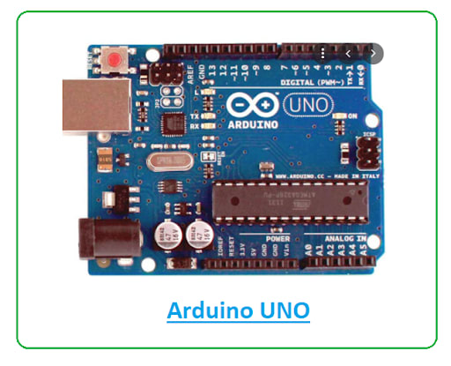
This board contains a USB interface i.e. USB cable is used to connect the board with the computer and Arduino IDE (Integrated Development Environment) software is used to program the board.
The unit comes with 32KB flash memory that is used to store the number of instructions while the SRAM is 2KB and EEPROM is 1KB.
The operating voltage of the unit is 5V which projects the microcontroller on the board and its associated circuitry operates at 5V while the input voltage ranges between 6V to 20V and the recommended input voltage ranges from 7V to 12V.
Do you like what you've read? Visit our Arduino Technology hub to read more great tech articles on Arduino!
What are the Arduino UNO specifications?
The Arduino UNO board contains the following components and specifications:
ATmega328 | This is the brain of the board in which the program is stored.
Ground Pin | there are several ground pins incorporated on the board.
PWM | the board contains 6 PWM pins. PWM stands for Pulse Width Modulation, using this process we can control the speed of the servo motor, DC motor, and brightness of the LED.
Digital I/O Pins | there are 14 digital (0-13) I/O pins available on the board that can be connected with external electronic components.
Analogue Pins | there are 6 analogue pins integrated on the board. These pins can read the analogue sensor and can convert it into a digital signal.
AREF | It is an Analog Reference Pin used to set an external reference voltage.
Reset Button | This button will reset the code loaded into the board. This button is useful when the board hangs up, pressing this button will take the entire board into an initial state.
USB Interface | This interface is used to connect the board with the computer and to upload the Arduino sketches (Arduino Program is called a Sketch)
DC Power Jack | This is used to power up the board with a power supply.
Power LED | This is a power LED that lights up when the board is connected with the power source.
Micro SD Card | The UNO board supports a micro SD card that allows the board to store more information.
3.3V | This pin is used to supply 3.3V power to your projects.
5V | This pin is used to supply 5V power to your projects.
VIN | It is the input voltage applied to the UNO board.
Voltage Regulator | The voltage regulator controls the voltage that goes into the board.
SPI | The SPI stands for Serial Peripheral Interface. Four Pins 10(SS), 11(MOSI), 12(MISO), 13(SCK) are used for this communication.

What is the pinout for the Arduino Uno?
There is a range of Arduino boards available in the market but the Arduino UNO is the most common board used in the electronic industry. The following figure shows the Arduino UNO Pinout for better understanding:
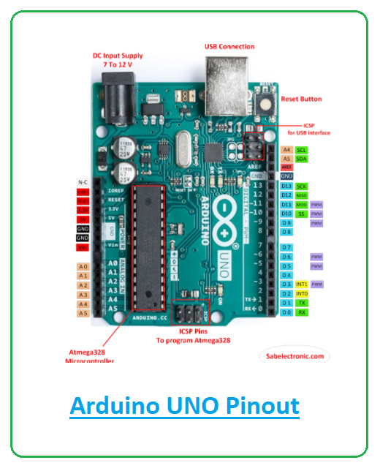
How do you Program Arduino UNO? Does it use C++?
Arduino UNO is easy to program and a person with little or no technical knowledge can get hands-on experience with this board. The Arduino UNO board is programmed using Arduino IDE software which is an official software introduced by Arduino.cc to program the board. The Arduino program is called a sketch which you need to unload into the board. The sketch is nothing but a set of instructions that allow the board to perform certain functions as per your requirements.
Each Arduino sketch comes with two main parts:
- void setup() – this sets up the things that need to be done once and they don’t happen again in the running program.
- void loop() – this part comes with the instructions that get repeated again and again until the board is turned off.
Difference between Arduino Board and Microcontroller:
Arduino boards can perform some functions that a single microcontroller is capable of doing. But hobbyists and experts still prefer the Arduino board over the microcontroller. Why? Because Arduino boards are easy to use and you don’t require a lot of expertise to run these units. Simply plug the board into the computer and start playing with it.
Moreover, while using Arduino boards, you don’t require extra peripherals and components to run the boards. Arduino is the complete board that comes with GPIO pins, analogue pins, and a microcontroller as the heart of the board. A microcontroller, on the other hand, is a chip where all the necessary parts like microprocessor, ram, and flash memory are incorporated into a single chip.
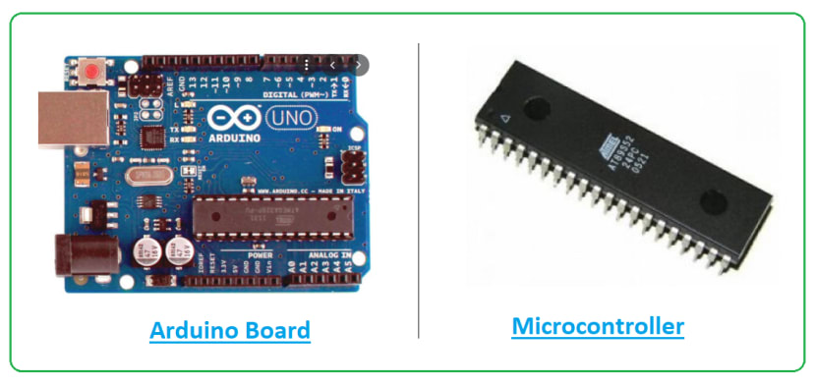
So we can say every Arduino board is a microcontroller but not every microcontroller is an Arduino board.
Plus, Arduino is an open-source hardware and software platform which means it is free to use and anyone can modify the boards as per their requirements.
What is an Arduino Uno used for?
The Arduino boards can work as a stand-alone project and can be interfaced with other Arduino boards or Raspberry Pi boards. Arduino UNO board is used in the following applications.
- Weighing Machines
- Traffic Light Count Down Timer
- Parking Lot Counter
- Embedded systems
- Home Automation
- Industrial Automation
- Medical Instrument
- Emergency Light for Railways
📦 Key Specifications:
Parameter | Value
Microcontroller | ATmega328P
Operating Voltage | 5V
Input Voltage (rec.) | 7–12V
Digital I/O Pins | 14 (of which 6 provide PWM output)
Analog Input Pins | 6
Flash Memory | 32 KB (0.5 KB used by bootloader)
SRAM | 2 KB
EEPROM | 1 KB
Clock Speed | 16 MHz
USB Interface | USB-B connector
Communication Protocols | UART, I2C, SPI

📌 Arduino Uno Pin Description:
🔹 1. Power Pins:
Pin | Function
VIN | Input voltage (7-12V) if using external power
5V | Regulated 5V output
3.3V | 3.3V output from onboard regulator
GND | Ground
RESET | Reset the microcontroller

🔹 2. Digital I/O Pins (0–13):
- Used for digital input/output (HIGH/LOW)
- Pins 0 (RX) and 1 (TX): Serial communication
- Pins 3, 5, 6, 9, 10, 11: Support PWM (analogWrite)

🔹 3. Analog Input Pins (A0–A5):
- Used to read analog voltages (0–5V) using a 10-bit ADC
- Can also be used as general digital I/O if needed
- A4 and A5 can also be used for I2C communication (SDA, SCL)

🔹 4. Special Function Pins:
Pin | Function
AREF | Reference voltage for analog inputs
RESET | Resets the board
IOREF | Provides the voltage reference for the board (usually 5V)

🔹 5. Communication Pins:
Protocol | Pins | Description
UART | 0 (RX), 1 (TX) | Serial communication
I2C | A4 (SDA), A5 (SCL) | I2C communication
SPI | 10 (SS), 11 (MOSI), 12 (MISO), 13 (SCK) | SPI interface

⚙️ Working Principle of Arduino Uno:
- Power Supply:
  - The board can be powered via USB or an external power source (VIN pin).
  - It includes onboard voltage regulators to provide 5V and 3.3V outputs.
- Microcontroller Operation:
  - The ATmega328P reads digital or analog inputs (sensors, buttons).
  - It executes instructions written in C/C++ using the Arduino IDE.
- Digital I/O:
  - These pins are used to read or output HIGH (5V) or LOW (0V) signals.
  - PWM pins simulate analog voltage using high-speed switching.
- Analog Inputs:
  - Read analog voltages using ADC (10-bit resolution: 0–1023).
  - Useful for sensors like temperature, potentiometers, etc.
- Communication:
  - Can communicate with other devices (sensors, modules, PCs) using UART, I2C, or SPI.
  - The USB port connects the board to a computer for uploading code and serial monitoring.
- Code Upload:
  - Programs (called sketches) are written in Arduino IDE and uploaded via USB.
  - A bootloader on the chip handles the upload without needing an external programmer.

🛠️ Applications:
- Home automation systems
- IoT devices and sensors
- Robotics and motor control
- Data acquisition systems
- Educational projects and prototypes

ARDUINO BASE BOARD DETAILS
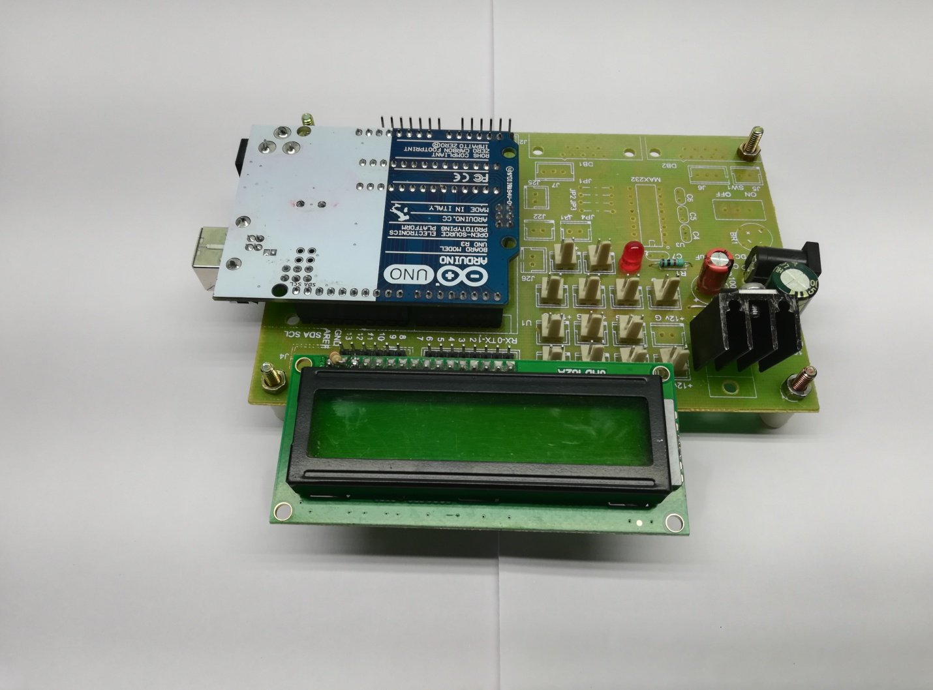
- 16*2 Lcd Display =01
- Dc Female Socket =01
- 1000/25v Capacitors =01
- 100/25v Capacitors =01
- 7805 Regulators =01
- 5mm Red Led =01
- 2pin Male Connectors=As Per Our ReQ
- Uno Base Board =01
- 1 K Resistor =01
- Male Bucks =01
- Female Bucks =01
- Arduino Micro Controller =01

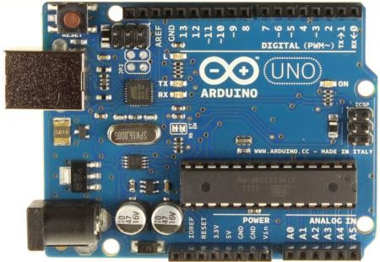
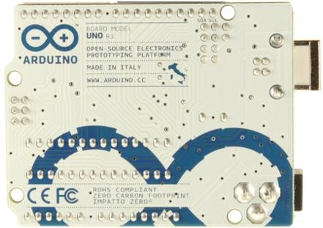
Arduino Uno R3 Front |  | Arduino Uno R3 Back
Arduino Uno R2 Front | Arduino Uno SMD | Arduino Uno Front | Arduino Uno Back

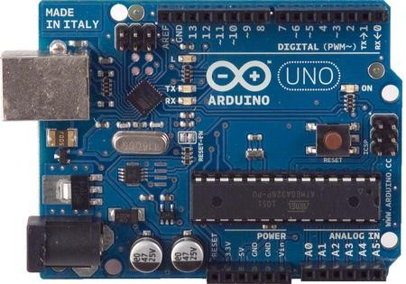
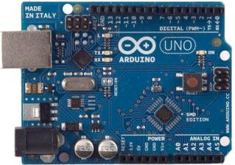
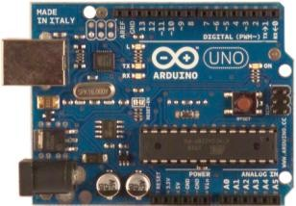
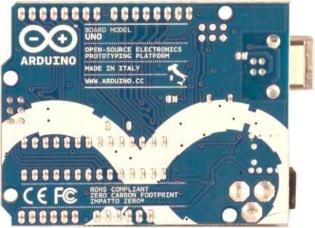
Overview

The Arduino Uno is a microcontroller board based on the ATmega328 (datasheet). It has 14 digital input/output pins (of which 6 can be used as PWM outputs), 6 analog inputs, a 16 MHz ceramic resonator, a USB connection, a power jack, an ICSP header, and a reset button. It contains everything needed to support the microcontroller; simply connect it to a computer with a USB cable or power it with a AC-to-DC adapter or battery to get started.
The Uno differs from all preceding boards in that it does not use the FTDI USB-to-serial driver chip. Instead, it features the Atmega16U2 (Atmega8U2 up to version R2) programmed as a USB-to-serial converter.
Revision 2 of the Uno board has a resistor pulling the 8U2 HWB line to ground, making it easier to put into DFU mode.
Revision 3 of the board has the following new features:

- 1.0 pinout: added SDA and SCL pins that are near to the AREF pin and two other new pins placed near to the RESET pin, the IOREF that allow the shields to adapt to the voltage provided from the board. In future, shields will be compatible both with the board that use the AVR, which operate with 5V and with the Arduino Due that operate with 3.3V. The second one is a not connected pin, that is reserved for future purposes.
- Stronger RESET circuit.
- Atmega 16U2 replace the 8U2.

"Uno" means one in Italian and is named to mark the upcoming release of Arduino 1.0. The Uno and version 1.0 will be the reference versions of Arduino, moving forward. The Uno is the latest in a series of USB Arduino boards, and the reference model for the Arduino platform; for a comparison with previous versions, see the index of Arduino boards.

The Arduino Uno (based on ATmega328P) supports several communication protocols, which are essential for interfacing with sensors, modules, other microcontrollers, and external devices.
Here's a list of communication protocols supported by the Arduino Uno, along with details of how they work and where they are used:

✅ Communication Protocols in Arduino Uno

1. 🔁 UART (Serial Communication)
Pins:
- Pin 0 (RX) – Receive data
- Pin 1 (TX) – Transmit data
Speed: Up to 115200 baud (default: 9600)
Library Used: Serial
Use Cases:
- Serial communication with PC via USB
- Communication with GSM modules (SIM800), GPS modules, Bluetooth (HC-05), etc.
Example:
Serial.begin(9600);
Serial.println("Hello from Uno");

2. 🔀 I2C (Inter-Integrated Circuit)
Pins on Uno:
- A4 (SDA) – Data line
- A5 (SCL) – Clock line
Library Used: Wire.h
Use Cases:
- Communicate with I2C devices like RTC (DS1307, DS3231), OLED displays, EEPROM, MPU6050, etc.
- Multiple slave devices (addressed by unique IDs) on the same two-wire bus
Example:
#include <Wire.h>
Wire.begin(); // Start I2C

3. 🔃 SPI (Serial Peripheral Interface)
Pins on Uno:
- 10 (SS) – Slave Select
- 11 (MOSI) – Master Out Slave In
- 12 (MISO) – Master In Slave Out
- 13 (SCK) – Serial Clock
Library Used: SPI.h
Use Cases:
- Fast communication with SD card modules, Ethernet modules, RF modules (NRF24L01), TFT LCDs, etc.
Example:
#include <SPI.h>
SPI.begin();

4. 📡 1-Wire (Software-Based Protocol)
Pin: Any digital pin (e.g., D2)
Library: OneWire.h
Use Cases:
- Communication with 1-Wire sensors like DS18B20 (temperature sensor)
Example:
#include <OneWire.h>
OneWire ds(2); // Pin 2 for 1-Wire

5. 🛰️ SoftwareSerial (Additional UART)
Pins: Any digital pins (customizable)
Library: SoftwareSerial.h
Use Cases:
- Create additional serial ports to communicate with GSM, GPS, Bluetooth while the main UART is used for Serial Monitor
Example:
#include <SoftwareSerial.h>
SoftwareSerial mySerial(7, 8); // RX, TX
mySerial.begin(9600);

6. 🧲 TWI (Two-Wire Interface)
- TWI is essentially the same as I2C, the name used in Atmel datasheets.
- Arduino uses the Wire library for TWI/I2C communication.

Summary Table:
Protocol | Pins Used | Speed | Devices Supported
UART | D0 (RX), D1 (TX) | 9600–115200 | Serial Monitor, GSM, GPS, Bluetooth
I2C / TWI | A4 (SDA), A5 (SCL) | ~100–400 kHz | OLED, EEPROM, RTC, Sensors
SPI | D10–D13 | ~1–8 MHz | SD Card, TFT, Ethernet, NRF24L01
SoftwareSerial | Any digital pins | Up to 57600 | Additional serial devices
1-Wire | Any digital pin | Slow | DS18B20, ROM-based ID sensors

🔄 Working Process:
1. Power Supply:
- Can be powered via USB, barrel jack, or VIN pin (7–12V).
- Internal regulators convert the voltage to a stable 5V and 3.3V for operation.
2. Bootloader and Firmware:
- The bootloader (pre-installed) allows you to upload code via USB without external programmers.
- When powered on, the bootloader runs first, then your uploaded program starts running from flash memory.
3. Reading Inputs:
- Digital pins (0–13): Read HIGH/LOW (5V/0V) signals from switches, buttons, IR receivers, etc.
- Analog pins (A0–A5): Read varying voltages (0–5V) from sensors like temperature, light, or potentiometers using a 10-bit ADC (0–1023).
4. Processing (Logic Control):
- The ATmega328P runs code line-by-line.
- It can make decisions using if, while, for loops, etc., based on sensor data or inputs.
5. Generating Outputs:
- Digital Outputs: Control LEDs, buzzers, relays, etc.
- PWM Outputs (Pins 3, 5, 6, 9, 10, 11): Control motor speed or LED brightness.
- Serial Outputs: Send data to the Serial Monitor or other devices.
6. Communication with External Devices:
- Uses protocols like UART, I2C, and SPI to interact with modules (GSM, LCDs, SD cards, RTCs, etc.)

✅ Why Arduino Uno is the Best Choice
The Arduino Uno is widely considered the best beginner-friendly and versatile microcontroller board, especially for students, makers, and even early-stage professionals. Here's why:

1. 🧩 Simple and Easy to Use
- Plug-and-play via USB
- Beginner-friendly programming with Arduino IDE
- No need for external programmer (built-in bootloader)

2. 💡 Well-Documented and Supported
- Massive open-source community support
- Countless tutorials, examples, and forums available
- Tons of libraries available for sensors and modules

3. 🧪 Reliable for Prototyping
- Enough GPIO pins for basic to moderate-level projects
- Easy to mount on breadboards or custom PCBs
- Stable 5V logic compatible with most electronics

4. 🔌 Good Hardware Features
Feature | Description
14 Digital I/O Pins | With PWM support on 6 pins
6 Analog Inputs | With 10-bit ADC
UART, I2C, SPI | For communication with other devices
5V / 3.3V Regulator | Power sensors and modules easily

5. 🧠 Enough Performance for Most Projects
- 16 MHz clock – fast enough for real-time tasks
- 32 KB Flash, 2 KB RAM – sufficient for most sensor and automation projects

6. 🔄 Cross-Platform and Expandable
- Runs on Windows, Linux, macOS
- Compatible with shields (plug-in boards for LCDs, motor drivers, etc.)
- Can be extended using SoftwareSerial, Interrupts, Timers, etc.

7. 🔐 Safe for Learning and Experimenting
- Hard to damage through simple mistakes
- Easy to reset and reprogram if needed

Arduino Architecture:
Arduino’s processor basically uses the Harvard architecture where the program code and program data have separate memory. It consists of two memories- Program memory and the data memory.The code is stored in the flash program memory, whereas the data is stored in the data memory. The Atmega328 has 32 KB of flash memory for storing code (of which 0.5 KB is used for the bootloader), 2 KB of SRAM and 1 KB of EEPROM and operates with a clock speed of 16MHz.
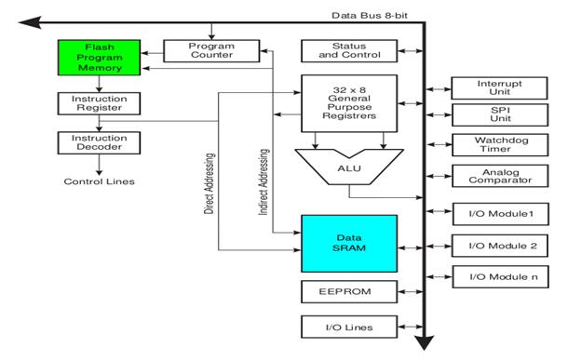

🔍 1. Major Components of Arduino Architecture

1️⃣ Microcontroller (ATmega328P)
- 8-bit AVR RISC architecture
- Executes instructions in a single clock cycle
- Power-efficient and suitable for real-time control

2️⃣ Memory Sections:
Memory Type | Size | Purpose
Flash | 32 KB | Stores program/sketch permanently
SRAM | 2 KB | Stores variables and data at runtime
EEPROM | 1 KB | Non-volatile memory to store settings

3️⃣ Digital I/O Pins (0–13)
- Can be configured as input or output
- Used to control devices (LEDs, motors, etc.)
- 6 pins support PWM (simulate analog output)

4️⃣ Analog Input Pins (A0–A5)
- Connected to an onboard 10-bit ADC
- Read analog voltage (0 to 5V) and convert to digital (0 to 1023)
- Can also be used as digital I/O

5️⃣ CPU (Central Processing Unit)
- Executes user-defined instructions stored in Flash memory
- Handles logic, arithmetic, branching, and data manipulation

6️⃣ Timers/Counters
- Hardware-based timers for:
  - Generating PWM
  - Measuring time intervals
  - Delays and task scheduling
- ATmega328P has 3 timers: Timer0 (8-bit), Timer1 (16-bit), Timer2 (8-bit)

7️⃣ Interrupts
- Hardware and software interrupts allow the CPU to react to events instantly
- Used for real-time tasks like detecting sensor input or timing operations

8️⃣ Communication Protocols
Protocol | Pins | Description
UART | 0 (RX), 1 (TX) | Serial communication with PC, GSM
I2C | A4 (SDA), A5 | Multi-device communication
SPI | 10–13 | Fast peripheral interfacing

9️⃣ ADC (Analog-to-Digital Converter)
- Converts analog signals to 10-bit digital values
- Sampled by analogRead() function

🔟 Power Management
- Operates at 5V
- Can be powered via:
  - USB (5V)
  - Barrel jack or VIN pin (7–12V)
- Onboard regulator ensures clean voltage supply

🔁 Reset and Bootloader
- Bootloader: Allows code uploading via USB without needing external programmer
- Reset button: Restarts the board and reinitializes the code

🧩 Software Layer Overview (Arduino IDE)
- Sketch (.ino file): Code written by the user
- Compiler: Converts sketch to machine code (hex file)
- Uploader: Sends hex code to microcontroller via USB
- Libraries: Abstract complex hardware tasks (I2C, SPI, etc.)

✅ Advantages of Arduino Architecture
- Simple and beginner-friendly
- Open-source (hardware + software)
- Modular and extendable
- Supported by a huge community
- Compatible with shields and hundreds of modules

📌 Real-World Application Examples
- Home automation (relay + sensor + GSM)
- Weather station (DHT + LCD)
- Line following robot (IR sensors + motor driver)
- IoT data logging (SD card + RTC)

Bluetooth Module (HC-05)

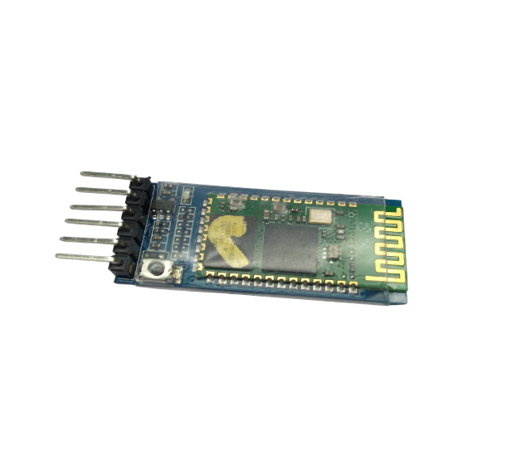
🔵 Bluetooth Module: HC-05
🔍 Overview
The HC-05 is a Bluetooth SPP (Serial Port Protocol) module designed for wireless serial communication between devices. It supports master and slave modes, making it ideal for connecting microcontrollers (like Arduino, STM32, Raspberry Pi) to other Bluetooth-enabled devices (like smartphones or other modules).

📦 Key Features
Feature | Description
Bluetooth Version | 2.0 + EDR (Classic Bluetooth)
Range | ~10 meters (up to 20m line-of-sight)
Voltage | 3.6V – 6V (internally regulated to 3.3V)
Logic Level | 3.3V TTL (⚠️ use voltage divider for RX pin if using 5V MCU)
Baud Rate | Default 9600 bps (configurable)
Modes | Master and Slave
Interface | UART (TX, RX, GND, VCC)
Communication | Full-duplex serial communication

📌 Pin Description (Typical HC-05 Module)
Pin | Function
VCC | Power supply (3.6V–6V)
GND | Ground
TXD | Transmit serial data
RXD | Receive serial data (⚠️ needs 3.3V logic)
STATE | Connection status (HIGH = connected)
EN/KEY | Mode selection (for AT command mode)

⚙️ How HC-05 Works
1️⃣ Power On
- When powered (VCC and GND), the HC-05 starts in slave mode by default.
- The onboard LED blinks rapidly, indicating it is ready to pair.

2️⃣ Pairing
- When paired with a Bluetooth-enabled device (e.g., smartphone), the LED blinks more slowly.
- Data can now be exchanged via serial.

3️⃣ Serial Communication (SPP Mode)
- Data sent from the microcontroller to the HC-05 is wirelessly transmitted to the paired device.
- Similarly, data from the paired device is received on the RX pin of the HC-05.
Example: Sending temperature data from Arduino to a mobile app via Bluetooth.

4️⃣ AT Command Mode (Configuration Mode)
To change settings like name, baud rate, or role:
- Pull the EN/KEY pin HIGH before power-on (or press button on some modules).
- Module enters AT command mode (LED blinks slowly).
- Use serial monitor or MCU to send AT commands.

🛠️ Common AT Commands
Command | Description
AT | Test connection (responds with OK)
AT+NAME=MyBT | Set module name
AT+ROLE=0 | Set as slave
AT+ROLE=1 | Set as master
AT+UART=9600,0,0 | Set baud rate (9600 bps)
AT+ADDR? | Get MAC address
AT+CMODE=0 | Connect to specific address
AT+BIND=xxxx,xx,xxxxxx | Bind to a specific MAC
AT commands must be sent at 38400 bps in command mode.

🧰 Applications
- Wireless serial communication with Arduino
- Home automation (Bluetooth-controlled lights, fans)
- Wireless robots (control via mobile app)
- Data logging to Android devices
- Wireless sensor communication
- PC-to-microcontroller serial interface

✅ Summary
Parameter | Description
Type | Bluetooth 2.0 (SPP)
Voltage | 3.6V – 6V
Interface | UART (TX/RX)
Modes | Master/Slave
Default Baud Rate | 9600 bps
Communication | Full-duplex serial
Use | Wireless serial bridge

🔵 Working of Bluetooth Module HC-05
The HC-05 module is a serial communication device that uses Bluetooth Classic (version 2.0 + EDR) to enable wireless data transfer between devices over a range of approximately 10–20 meters.
It acts as a wireless replacement for serial communication (UART), allowing two devices to send and receive data without physical cables.

🧭 Step-by-Step Working Process

1️⃣ Powering the Module
- The HC-05 operates on 3.6V to 6V input voltage.
- Internally, it works at 3.3V logic, so care must be taken if using 5V microcontrollers (like Arduino Uno).
- When powered on, the onboard LED blinks rapidly indicating it is in pairing mode.

2️⃣ Default Mode: Slave Mode
- By default, HC-05 starts in Slave Mode.
- It waits to receive a Bluetooth connection from a Master device like:
  - A smartphone
  - A PC/laptop
  - Another HC-05 in master mode

3️⃣ Pairing and Connection
- When a Bluetooth device discovers and connects to the HC-05 (default name is "HC-05", default PIN is "1234" or "0000"), the LED blinking slows down, indicating successful pairing.
- Once paired, the two devices can send and receive serial data wirelessly, just like a wired UART connection.

4️⃣ Serial Communication
- HC-05 uses UART (TX and RX pins) to communicate with microcontrollers.
- It transparently transmits any serial data it receives from the microcontroller to the connected Bluetooth device.
- Likewise, it receives data from the paired device and forwards it to the microcontroller over UART.
📥 Example Use:
Arduino sends: "Temperature = 27°C"
HC-05 transmits wirelessly → Mobile app receives the message
📤 Reverse Example:
User sends "ON" from mobile app → HC-05 → Arduino turns LED ON

5️⃣ AT Command Mode (Configuration Mode)
- To change settings like name, baud rate, or mode, HC-05 can be put into AT Command Mode.
- This is done by:
  - Holding the "KEY"/EN pin HIGH while powering on.
  - The LED blinks slowly (once every 2 seconds), indicating AT mode is active.
- In this mode, commands can be sent at 38400 bps.
🔧 Common AT Commands:
Command | Function
AT | Test connection (OK)
AT+NAME=Device1 | Change device name
AT+ROLE=1 | Set to Master mode
AT+ROLE=0 | Set to Slave mode
AT+UART=9600,0,0 | Set baud rate
AT+PSWD=1234 | Set pairing password

6️⃣ Modes of Operation
Mode | Description
Slave (default) | Waits for connections from a master
Master | Initiates connection to another HC-05 or Bluetooth device
Only one device can connect to HC-05 at a time.

⚙️ How It Works Internally
+--------------------------+
| Bluetooth RF Module |
+--------------------------+
| Serial Communication Unit|
| - TX, RX (UART) |
+--------------------------+
| Flash ROM & Config Logic|
| - Stores settings |
+--------------------------+
| Status LED |
+--------------------------+

🔁 Real-Life Working Example: Arduino + HC-05 + Android
- Arduino sends temperature data via Serial.println()
- HC-05 sends it over Bluetooth
- Android app (like Serial Bluetooth Terminal) receives and displays the data
- User types “ON” in the app → Arduino receives it and turns on an LED

✅ Summary of HC-05 Working
Step | Function
1 | Power on (LED blinks fast = pairing mode)
2 | Connect to a Bluetooth device (LED blinks slow = connected)
3 | Communicate over UART (TX/RX pins)
4 | Optional: Use AT commands to configure settings
5 | Data sent from one device is received wirelessly by the other

📦 Applications
- Wireless control of Arduino/robots
- Home automation systems
- Bluetooth-based sensor monitoring
- Android-app-based wireless devices
- Serial cable replacement

16x2 LCD

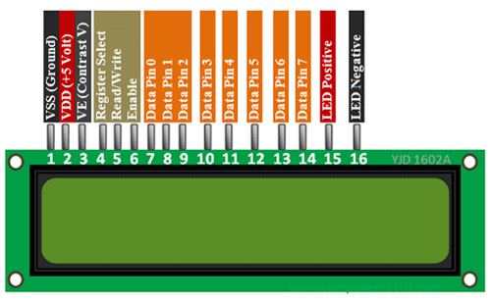

Description of 16x2 LCD Display and Its Pin Working
A 16x2 LCD display is a standard character LCD module that can display 16 characters per row on 2 lines. It is based on the HD44780 controller, which is widely used in embedded systems, Arduino, and microcontroller projects.
This display works in 8-bit or 4-bit parallel mode, where the microcontroller sends data and commands to control what is shown on the screen.

Specifications of 16x2 LCD
Feature | Description
Display Format | 16 characters × 2 lines
Controller | HD44780 or compatible
Interface | 8-bit or 4-bit parallel
Operating Voltage | 4.7V to 5.3V (typ. 5V)
Character Size | 5×8 dot matrix
Backlight | LED (yellow-green/blue variants)
Contrast Control | Via external potentiometer

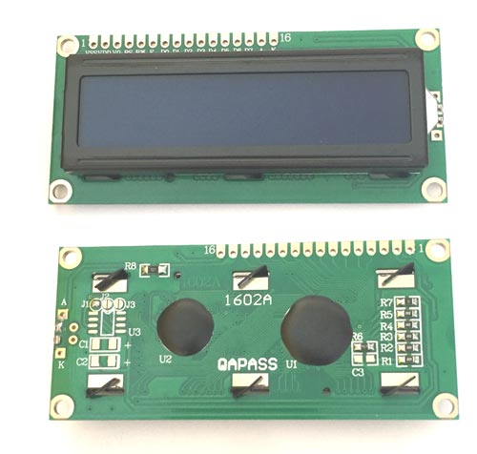
Pinout of 16x2 LCD Module
The LCD has 16 pins, which are described below:
Pin | Name | Function
1 | VSS | Ground — connect to GND.
2 | VDD | +5V power supply — connect to 5V.
3 | V0 | Contrast adjust — connect to a potentiometer to control display contrast.
4 | RS (Register Select) | Selects register: 0 = Command, 1 = Data.
5 | RW (Read/Write) | 0 = Write, 1 = Read. Usually grounded for write-only mode.
6 | E (Enable) | Starts data read/write. A high-to-low pulse on this pin enables the LCD to latch the data.
7–14 | D0–D7 (Data pins) | These are the data bus lines. In 8-bit mode, all D0–D7 are used. In 4-bit mode, only D4–D7 are used.
15 | LED+ (A) | Backlight anode — connect to 5V via resistor if needed.
16 | LED– (K) | Backlight cathode — connect to GND.

How the 16x2 LCD Works
- The microcontroller sends commands (like clear display, set cursor) or data (characters to display) to the LCD using the RS, E, and data pins.
- In 4-bit mode, data is sent in two steps using only D4–D7 to save I/O pins.
- The LCD uses an internal DDRAM (Display Data RAM) where each byte corresponds to a character on screen.
- The Enable (E) pin is pulsed to latch data from MCU.
- Contrast is adjusted by applying voltage to V0 pin, usually via a 10kΩ potentiometer.

LCD 16x2 Commands
While interfacing an LCD16x2 with any microcontroller, firstly we need to initialize the LCD. For that, we need to send some commands. Similarly, to clear the display or for changing the position we need to send commands. So basically, we can say that LCD16x2 is controlled by using commands.
Commonly Used LCD16x2 Commands
Code (HEX) | Command to LCD | Execution Time
0x01 | Clear the display screen | 1.64ms
0x06 | Shift the cursor right (e.g. data gets written in an incrementing order, left to right) | 40 us
0x0C | Display on, cursor off | 40 us
0x0E | Display on, cursor blinking | 40 us
0x80 | Force the cursor to the beginning of the 1st line | 40 us
0xC0 | Force the cursor to the beginning of the 2nd line | 40 us
0x10 | Shift cursor position to the left | 40 us
0x14 | Shift cursor position to the right | 40 us
0x18 | Shift entire display to the left | 40 us
0x1C | Shift entire display to the right | 40 us
0x38 | 2 lines, 5x8 matrix, 8-bit mode | 40 us
0x28 | 2 lines, 5x8 matrix,4-bit mode | 40 us
0x30 | 1 line, 8-bit mode | 40us
0x20 | 1 line, 4-bit mode | 40us
Now, while printing a character on LCD16x2, we need to send the ASCII code of that character to LCD16x2. Suppose, we want to print a character ‘H’ on the LCD, then we should send 0x48 (ASCII code of ‘H’) data to the LCD16x2. The LCD16x2 has its own controller, which does the printing job on the LCD16x2.

LCD 16x2 4-bit Mode Configuration
Only four GPIO pins are connected to LCD data (D4-D7) pin which helps to save GPIO pins. By default, LCD16x2 is in 8-bit mode. To use LCD16x2 in 4-bit mode, we need to send some commands for LCD initialization and configuration. To send these commands following data formats should follow.
D7 | D6 | D5 | D4 | D3 | D2 | D1 | D0
0 | 0 | 1 | DL | N | F | - | -

DL: Interface Data length
0 =4-bit
1 = 8-bit
N: Number of display lines
0 = 1 line
1 = 2 line
F: Character Font
0 = 5x8 dots
1 = 5x10 dots
D1:D0: These bits are set to 0.
D7:D6: These bits are set to 0.
D5: This bit should set to 1.
Note: To configure LCD 16x2 in a 4-bit mode, we should send 2 at higher nibble (D4 - D7) to LCD 16x2. As only four (D4 - D7) data lines need to be connected to the microcontroller, we need to send 0x02 as a command, which will write 0 to higher nibble (D4-D7) and then again write 2 to higher nibble, which will set the LCD in 4-bit mode. Note that we can provide any command with lower nibble as 2 i.e. 0x32, 0x42 etc. except 0x22 to initialize display in 4-bit mode.

LCD 16x2 Custom Character
lets see how to display the custom character on LCD16x2 display.
LCD16x2 can display user defined custom characters. This can be used for displaying symbols and different patterns.
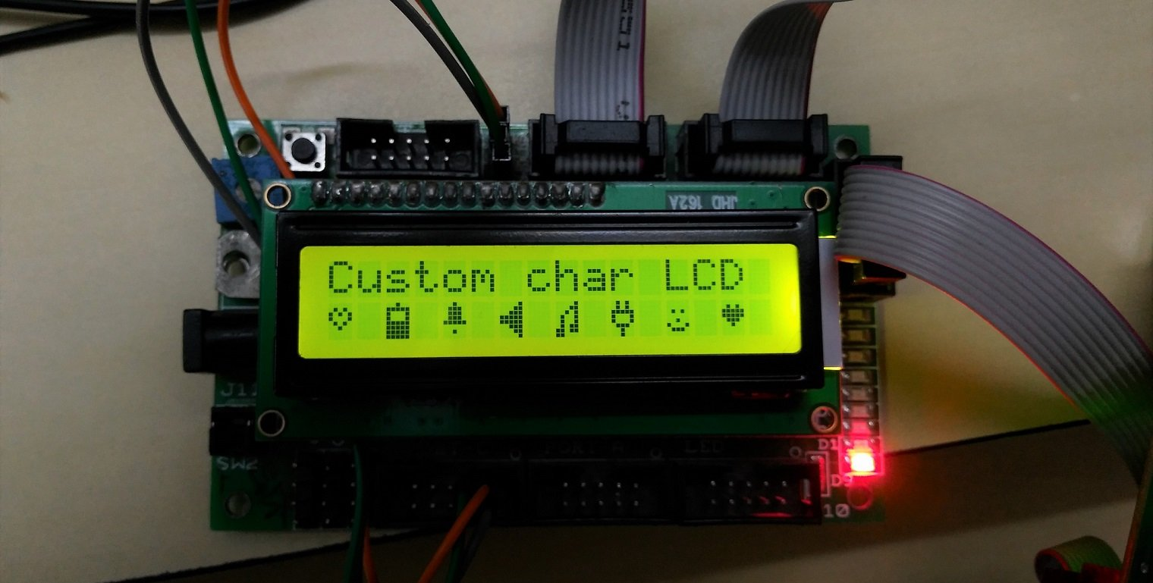

As we know, to print character symbol on LCD, we have to send ASCII code. LCD16x2 also has feature, where we can print our own custom character, which is not included in ASCII set of character.
E.g. J, ©, ∞ etc.
CGRAM
LCD16x2 has memory space of 64 bytes called as CGRAM (character generator RAM). It is used to make custom patterns. We just have to write custom pixel values in this memory space.
Command | Code |  |  |  |  | Description | Execution Time
Command | RS | R/W | DB7 | DB6 | DB5-DB0 | Description | Execution Time
Set CGRAM Address | 0 | 0 | 0 | 1 | Address | This is used to set the address of CGRAM. | 40us
While providing the address of CGRAM, we have to keep DB6 line always high. This means that address starts from 0x40 to store custom character on CGRAM.

How to Build custom character for LCD16x2
On LCD16x2 one character is made up by 5x8 pixel matrix. Consider that we have to design Bell shape custom character. As in diagram, we have to define pixel values, 0 for pixel OFF and 1 for Pixel ON.
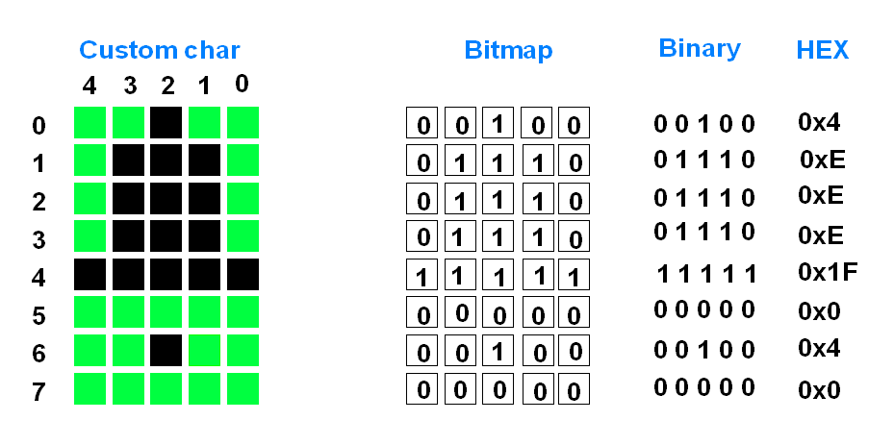Custom Character Representation

So, we get total eight values for one custom character.
Storing Custom Character
Custom Characters are stored at CGRAM’s memory location. CGRAM is 64 bytes.
Custom character address starts from 0x40 and ends at 0x7F.
So we can define total 8 custom characters.
Character No. | CGRAM Address
1 | 0x40 - 0x47
2 | 0x48 - 0x4F
3 | 0x50 - 0x57
4 | 0x58 - 0x5F
5 | 0x60 - 0x67
6 | 0x68 - 0x6F
7 | 0x70 - 0x77
8 | 0x78 - 0x7F

Advantages
- Easy to Interface
  - Works well with microcontrollers like Arduino, STM32, ESP32 using either 4-bit or 8-bit parallel communication.
- Low Cost and Widely Available
  - Very affordable and commonly used in embedded systems and hobby projects.
- Readable in Sunlight
  - With proper backlight, it offers good readability even in bright environments.
- Custom Character Support
  - Can display user-defined characters (up to 8 custom characters) using CGRAM.
- Low Power Consumption
  - Consumes very little power, especially if the backlight is turned off.
- Stable Display
  - Once data is written, it stays until changed, making it suitable for static displays like temperature, time, etc.
- Multiple Language Support
  - Supports various character sets (English, Japanese, etc.) with internal ROM selection (in some models).

Disadvantages
- Limited to Text Only
  - Cannot display images or graphics; only characters and symbols.
- Slower Updates
  - Updating data on the screen takes longer compared to OLED or TFT displays.
- Bulky Size
  - Larger and thicker than modern display technologies like OLEDs, making it less ideal for compact devices.
- Parallel Interface Needs More Pins
  - Requires many I/O pins in 8-bit mode. Even in 4-bit mode, 6+ wires are still needed unless using I2C converter.
- Low Resolution
  - Limited to 16 characters × 2 lines — not suitable for applications needing detailed or multi-line displays.
- Viewing Angle is Limited
  - Angle of view is narrower compared to TFT or OLED displays; clarity reduces from side angles.
- Contrast Needs Tuning
  - Needs an external potentiometer to adjust contrast, which adds a component and slight complexity.
SERVO Motor (SG90)

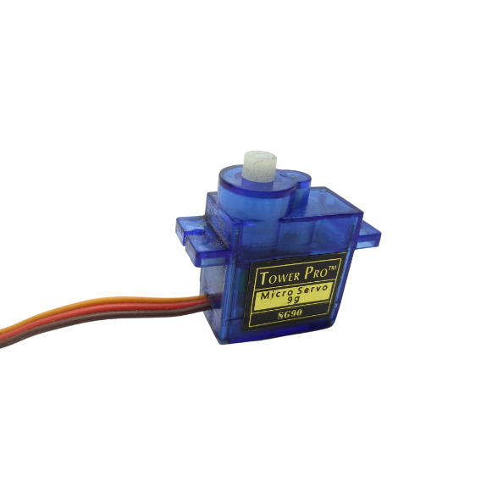

Description of SG90 Servo Motor and Its Working

The SG90 is a micro servo motor commonly used in hobby electronics, robotics, and embedded systems. It is lightweight, compact, and provides precise angular rotation control, typically used in applications like robotic arms, sensor movement, RC planes, or DIY projects.
The SG90 is controlled via Pulse Width Modulation (PWM) signals and is known for its torque, stability, and ease of use with platforms like Arduino and Raspberry Pi.

Working Principle of SG90 Servo Motor
The SG90 servo motor works on the principle of closed-loop control, combining:
- DC motor – Provides the rotation.
- Gearbox – Reduces speed and increases torque.
- Position sensor (potentiometer) – Monitors the current angle of the shaft.
- Control circuit – Compares desired angle (from input PWM) with actual shaft position and adjusts the motor accordingly.

How It Works (PWM Control)
- The motor angle is controlled by PWM signals (Pulse Width Modulation).
- Pulse duration determines the angle of the output shaft:
  - 1 ms pulse → ~0° (minimum position)
  - 1.5 ms pulse → ~90° (neutral/mid position)
  - 2 ms pulse → ~180° (maximum position)
- PWM frequency is typically 50 Hz (20 ms cycle).
The internal controller reads the PWM signal and rotates the motor shaft to match the requested position, using feedback from the internal potentiometer.

SG90 Servo Motor Pin Description (3 pins)
Pin | Color | Function
VCC | Red | Power supply (typically 5V)
GND | Brown | Ground
PWM | Orange | PWM control signal (from microcontroller)

Specifications
Parameter | Value
Operating Voltage | 4.8V to 6V
Torque (at 4.8V) | ~1.8 kg·cm
Operating Speed (4.8V) | ~0.1 s/60°
Rotation Angle Range | 0° to ~180°
Weight | ~9 grams
Dimensions | 22.2 × 11.8 × 31 mm
Gear Type | Plastic gears
Control Signal | PWM (50 Hz)

Applications
- Robotic arms and joints
- Sensor direction control
- RC cars, boats, planes
- Automated door locks or small actuators
- Arduino projects with position control

How to use a Servo Motor
After selecting the right Servo motor for the project, comes the question how to use it. As we know there are three wires coming out of this motor. The description of the same is given on top of this page. To make this motor rotate, we have to power the motor with +5V using the Red and Brown wire and send PWM signals to the Orange colour wire. Hence we need something that could generate PWM signals to make this motor work, this something could be anything like a 555 Timer or other Microcontroller platforms like Arduino, PIC, ARM or even a microprocessor like Raspberry Pie. Now, how to control the direction of the motor? To understand that let us a look at the picture given in the datasheet.
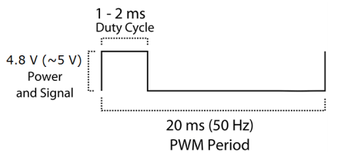
From the picture we can understand that the PWM signal produced should have a frequency of 50Hz that is the PWM period should be 20ms. Out of which the On-Time can vary from 1ms to 2ms. So when the on-time is 1ms the motor will be in 0° and when 1.5ms the motor will be 90°, similarly when it is 2ms it will be 180°. So, by varying the on-time from 1ms to 2ms the motor can be controlled from 0° to 180°. If you want to learn more you can check out the Basics of Servo Motor article.

SG90 Servo Motor Dimensions
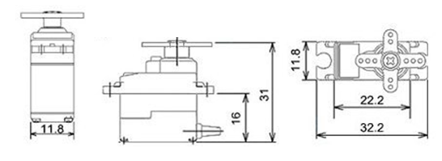

Advantages
- Compact and Lightweight
  - Weighs around 9g, perfect for small-scale projects like robotics, RC vehicles, and wearables.
- Precise Position Control
  - Offers accurate angular movement (typically from 0° to 180°) using PWM signals.
- Low Power Requirement
  - Operates at 4.8V to 6V, making it ideal for use with Arduino, Raspberry Pi, and other microcontrollers.
- Easy to Interface
  - Requires only 3 connections (VCC, GND, and PWM) — no complex driver circuits needed.
- Affordable and Widely Available
  - Cost-effective solution for hobbyists and beginners.
- Good Torque for Small Devices
  - Delivers ~1.8 kg·cm torque, enough for small mechanical movements.
- Built-in Gearbox and Feedback Mechanism
  - Integrated system eliminates the need for external feedback control.

Disadvantages
- Limited Rotation Range
  - Can only rotate up to ~180°; not suitable for continuous rotation or full circular motion.
- Plastic Gears
  - Internal gears are made of plastic, which wear out or break under heavy load or rough use.
- Low Torque for Heavy Applications
  - Not powerful enough for large-scale or industrial-grade mechanical systems.
- Noisy Operation
  - May produce noticeable mechanical noise during movement.
- Sensitive to Power Fluctuations
  - Inconsistent voltage or low current supply can cause jitter or improper functioning.
- Requires Constant PWM Signal
  - Needs a continuous signal to hold position; otherwise, it may drift or lose torque.
- Cannot Read Actual Position Externally
  - No direct way to read the current position from the servo (internal feedback is not accessible).

L298N Driver

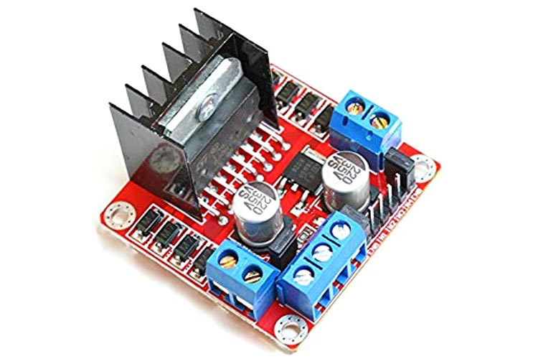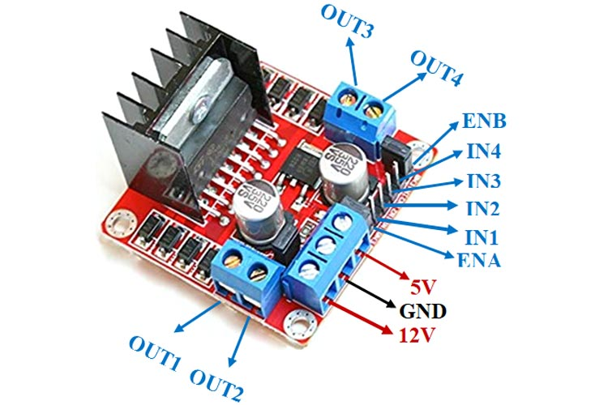

L298N Motor Driver – Description and Working
The L298N motor driver is a dual full H-Bridge driver module used to control the speed and direction of two DC motors or one stepper motor. It is widely used in robotics and embedded projects where motor control is required using a microcontroller like Arduino, Raspberry Pi, or STM32.

General Description:
- IC Type: L298N (dual H-Bridge)
- Module Supply Voltage: 5V to 35V
- Logic Voltage: 5V
- Max Current: Up to 2A per motor channel
- Motor Control: 2 DC motors (independently), or 1 stepper motor
- Built-in 5V Regulator: Can power microcontrollers (when jumper is used)

Main Components on the L298N Module:
- L298N IC
- Terminal blocks for motor and power connections
- 5V regulator (optional via jumper)
- Heatsink for cooling
- Jumper caps for enabling internal voltage regulation

Pin Description:
Pin Name | Function
IN1, IN2 | Motor A direction control inputs
IN3, IN4 | Motor B direction control inputs
ENA (Enable A) | Enables or disables Motor A (can be connected to PWM for speed control)
ENB (Enable B) | Enables or disables Motor B (can be connected to PWM for speed control)
OUT1, OUT2 | Motor A outputs
OUT3, OUT4 | Motor B outputs
VCC | Motor power supply (up to 35V)
GND | Ground (common ground for motor and logic)
5V | Logic voltage input/output (used only if the 5V regulator jumper is removed)

Working Principle:
1. Direction Control:
Each motor is controlled using two input pins:
- IN1 and IN2 control Motor A
- IN3 and IN4 control Motor B
IN1 | IN2 | Motor A Direction
HIGH | LOW | Forward
LOW | HIGH | Reverse
LOW | LOW or HIGH | Motor stops
Same logic applies to IN3 and IN4 for Motor B.

2. Speed Control:
- ENA and ENB are the enable pins.
- If connected to HIGH (5V), the motor runs at full speed.
- If connected to a PWM signal, the motor speed can be controlled.

3. Power Supply:
- VCC: Connect motor power (e.g., 12V battery)
- 5V Pin:
  - If jumper is connected: L298N supplies 5V logic to microcontroller
  - If jumper is removed: External 5V must be given for logic

Example Use Case (DC Motor):
- IN1 = HIGH, IN2 = LOW → Motor A runs forward
- IN1 = LOW, IN2 = HIGH → Motor A runs backward
- ENA = PWM signal → Control speed

Brief about L298N Module
The L298N Motor Driver module consists of an L298 Motor Driver IC, 78M05 Voltage Regulator, resistors, capacitor, Power LED, 5V jumper in an integrated circuit.
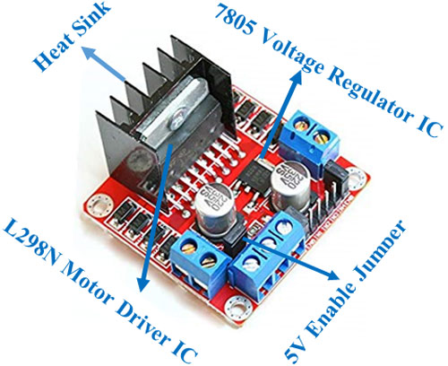
78s05 Voltage regulator will be enabled only when the jumper is placed. When the power supply is less than or equal to 12V, then the internal circuitry will be powered by the voltage regulator and the 5V pin can be used as an output pin to power the microcontroller. The jumper should not be placed when the power supply is greater than 12V and separate 5V should be given through 5V terminal to power the internal circuitry.

ENA & ENB pins are speed control pins for Motor A and Motor B while IN1& IN2 and IN3 & IN4 are direction control pins for Motor A and Motor B.
Internal circuit diagram of L298N Motor Driver module is given below:
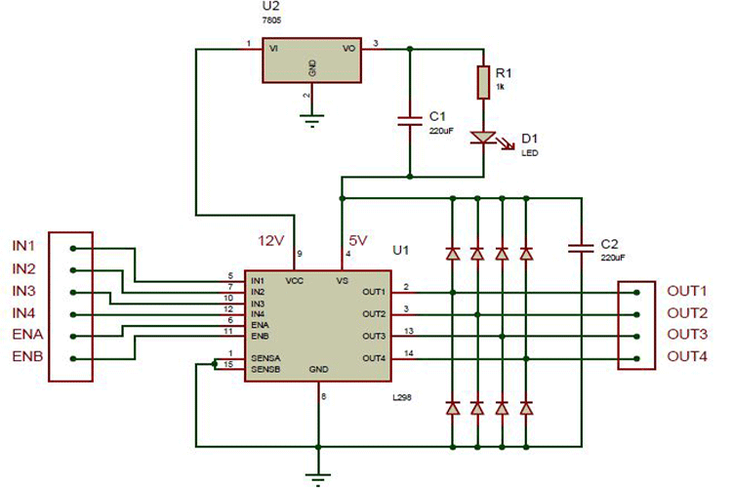

Applications:
- Smart robot cars
- Conveyor belts
- Stepper motor control
- CNC machines
- Arduino robotics projects

Advantages:
- Can control two motors independently
- Supports PWM speed control
- Handles higher voltage and current than L293D
- Built-in 5V regulator (optional)

Disadvantages:
- Requires external heatsink or fan for high loads
- Bulky compared to modern motor drivers
- Voltage drops slightly across H-Bridge (not 100% efficient)

DC toy motor(Bo motor)
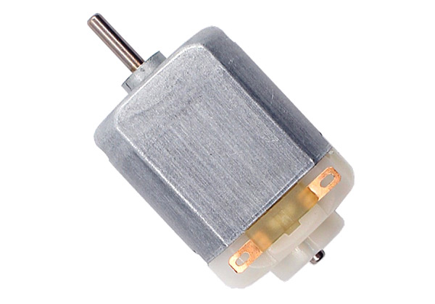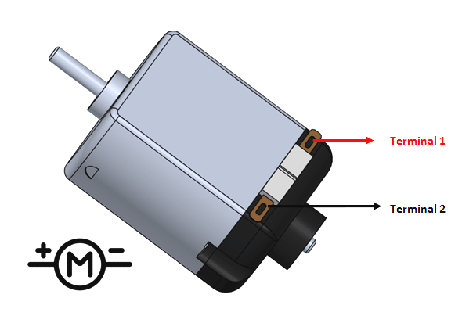

A DC toy motor is a small, lightweight brushed DC motor commonly used in low-power applications like toys, hobby kits, and small electronics.
- Voltage Ratings: Usually 3V, 6V, or 9V
- Speed: Very high (up to 12,000 RPM)
- Torque: Low
Working:
- When powered by a battery or low-voltage source, current flows through the armature.
- A magnetic field is created, which interacts with the permanent magnets inside.
- This causes the rotor to spin rapidly.
- Often used to directly spin wheels, propellers, or small fans.

DC Motor Specifications:
- Voltage rating (e.g., 6V, 12V, 24V)
- Current rating
- RPM (speed)
- Torque
- Shaft diameter
- Motor size

Applications:
- Toy cars and drones
- Small fans and pumps
- Conveyor belts
- Home appliances
- Robotics and automation systems

Advantages:
- Easy to control speed and direction
- Simple construction and low cost
- Quick start and stop response
- High starting torque

Disadvantages:
- Brushes wear out over time (in brushed motors)
- Produces electrical noise due to commutation
- Requires regular maintenance
- Less efficient than BLDC motors

ULTRASONIC Sensor
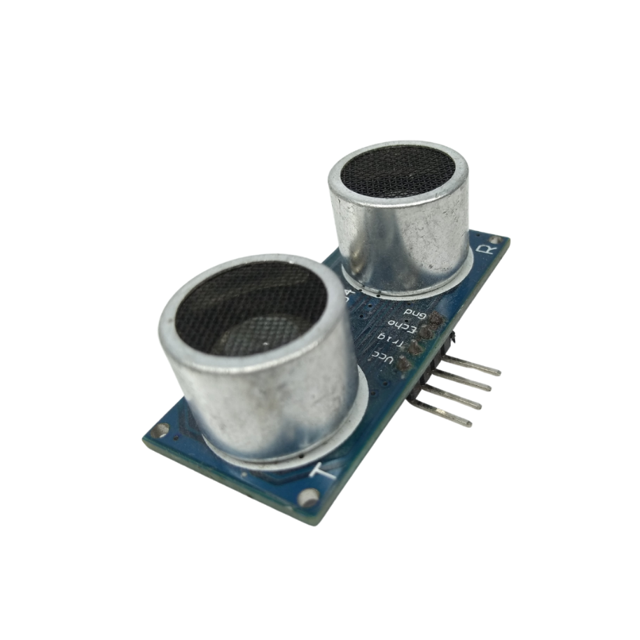

Description:
The 4-pin Ultrasonic Sensor (commonly the HC-SR04 module) is used to measure distance using ultrasonic sound waves. It is widely used in robotics, obstacle detection, automatic parking, liquid level detection, and object counter systems.
It works on the time-of-flight principle — sending an ultrasonic pulse and measuring the time it takes to bounce back after hitting an object.

Pin Description:
Pin | Name | Function
1 | VCC | Power supply (+5V)
2 | Trig | Trigger pin – input to start measurement
3 | Echo | Echo pin – output pulse duration = time of flight
4 | GND | Ground

Working Principle:
- Triggering:
A 10μs HIGH pulse is sent to the Trig pin to start the measurement.
- Ultrasonic Emission:
The sensor sends an 8-cycle ultrasonic pulse at 40 kHz from the transmitter.
- Reflection:
The sound wave hits an object and reflects back.
- Echo Reception:
The Echo pin goes HIGH for the duration that the sound wave travels to the object and back.
- Time Measurement:
The microcontroller measures the HIGH time of the Echo pin.
- Distance Calculation:
Distance (cm)=Time (μs)×0.03432\text{Distance (cm)} = \frac{\text{Time (μs)} \times 0.0343}{2}Distance (cm)=2Time (μs)×0.0343​
  - Speed of sound = 343 m/s = 0.0343 cm/μs
  - Divide by 2 (forward and return path)

Key Points:
- Minimum distance: ~2 cm
- Maximum distance: ~400 cm
- Measurement accuracy: ±3 mm
- Sensing angle: ~15°

Applications:
- Obstacle avoiding robots
- Distance measurement devices
- Level detection (tank/liquid)
- Home automation (door openers)
- Smart parking systems
1. Specifications:
Parameter | Value
Model | HC-SR04
Operating Voltage | 5V DC
Operating Current | 15 mA (typical)
Frequency | 40 kHz (ultrasonic pulse)
Measuring Range | 2 cm to 400 cm (0.02 m to 4 m)
Accuracy | ±3 mm
Resolution | 0.3 cm
Sensor Angle | ~15° (effective cone angle)
Trigger Input Signal | 10 μs HIGH TTL pulse
Echo Output Signal | TTL pulse (duration = time of flight)
Dimensions | ~45mm x 20mm x 15mm
Interface | 4-Pin (VCC, Trig, Echo, GND)

2. Advantages:
- Non-contact measurement – no physical contact with the object
- Affordable and widely available
- Easy to interface with microcontrollers (Arduino, ESP32, etc.)
- Fast response time
- Good range (2 cm to 4 meters)
- High accuracy for low-cost sensor
- Simple to use with digital I/O

3. Disadvantages:
- Sensitive to environmental noise
  - E.g., wind, temperature, soft materials (cloth, foam) absorb sound
- Limited angle of detection (~15°)
- Affected by ambient temperature (since sound speed varies)
- Not suitable for underwater or vacuum
- Not ideal for very small or angled objects (may not reflect sound properly)

4. Applications:
Field | Application
Robotics | Obstacle detection and avoidance
Automotive | Reverse parking sensors
Smart Agriculture | Water level sensing in tanks or reservoirs
Home Automation | Touchless taps, automatic doors
Industrial | Object counters, conveyor belt detection
IoT Projects | Distance alert systems, security-based alarms
Medical | Proximity-based hygiene tools (e.g., sanitizer dispensers)

SOFTWARE DESCRIPTION

This project is implemented using following software’s:
- Express PCB – for designing circuit
- Arduino IDE compiler - for compilation part
Express PCB:
Breadboards are great for prototyping equipment as it allows great flexibility to modify a design when needed; however the final product of a project, ideally should have a neat PCB, few cables, and survive a shake test. Not only is a proper PCB neater but it is also more durable as there are no cables which can yank loose.
Express PCB is a software tool to design PCBs specifically for manufacture by the company Express PCB (no other PCB maker accepts Express PCB files). It is very easy to use, but it does have several limitations.
It can be likened to more of a toy then a professional CAD program.
It has a poor part library (which we can work around)
It cannot import or export files in different formats
It cannot be used to make prepare boards for DIY production
Express PCB has been used to design many PCBs (some layered and with surface-mount parts. Print out PCB patterns and use the toner transfer method with an Etch Resistant Pen to make boards. However, Express PCB does not have a nice print layout. Here is the procedure to design in Express PCB and clean up the patterns so they print nicely.

Preparing Express PCB for First Use:
Express PCB comes with a less then exciting list of parts. So before any project is started head over to Audio logical and grab the additional parts by morsel, ppl, and tangent, and extract them into your Express PCB directory. At this point start the program and get ready to setup the workspace to suit your style.
Click View -> Options. In this menu, setup the units for “mm” or “in” depending on how you think, and click “see through the top copper layer” at the bottom. The standard color scheme of red and green is generally used but it is not as pleasing as red and blue.
The Interface:
When a project is first started you will be greeted with a yellow outline. This yellow outline is the dimension of the PCB. Typically after positioning of parts and traces, move them to their final position and then crop the PCB to the correct size. However, in designing a board with a certain size constraint, crop the PCB to the correct size before starting.
Fig: 4.1 show the toolbar in which the each button has the following functions:
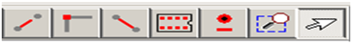
Fig 4.1: Tool bar necessary for the interface
- The select tool: It is fairly obvious what this does. It allows you to move and manipulate parts. When this tool is selected the top toolbar will show buttons to move traces to the top / bottom copper layer, and rotate buttons.
- The zoom to selection tool: does just that.
- The place pad: button allows you to place small soldier pads which are useful for board connections or if a part is not in the part library but the part dimensions are available. When this tool is selected the top toolbar will give you a large selection of round holes, square holes and surface mount pads.
- The place component: tool allows you to select a component from the top toolbar and then by clicking in the workspace places that component in the orientation chosen using the buttons next to the component list. The components can always be rotated afterwards with the select tool if the orientation is wrong.
- The place trace: tool allows you to place a solid trace on the board of varying thicknesses. The top toolbar allows you to select the top or bottom layer to place the trace on.
- The Insert Corner in trace: button does exactly what it says. When this tool is selected, clicking on a trace will insert a corner which can be moved to route around components and other traces.
- The remove a trace button is not very important since the delete key will achieve the same result.
Design Considerations:
Before starting a project there are several ways to design a PCB and one must be chosen to suit the project’s needs.
Single sided, or double sided?
When making a PCB you have the option of making a single sided board, or a double sided board. Single sided boards are cheaper to produce and easier to etch, but much harder to design for large projects. If a lot of parts are being used in a small space it may be difficult to make a single sided board without jumpering over traces with a cable. While there’s technically nothing wrong with this, it should be avoided if the signal travelling over the traces is sensitive (e.g. audio signals).
A double sided board is more expensive to produce professionally, more difficult to etch on a DIY board, but makes the layout of components a lot smaller and easier. It should be noted that if a trace is running on the top layer, check with the components to make sure you can get to its pins with a soldering iron. Large capacitors, relays, and similar parts which don’t have axial leads can NOT have traces on top unless boards are plated professionally.
Ground-plane or other special purposes for one side
When using a double sided board you must consider which traces should be on what side of the board. Generally, put power traces on the top of the board, jumping only to the bottom if a part cannot be soldiered onto the top plane (like a relay), and vice- versa.
Some projects like power supplies or amps can benefit from having a solid plane to use for ground. In power supplies this can reduce noise, and in amps it minimizes the distance between parts and their ground connections, and keeps the ground signal as simple as possible. However, care must be taken with stubborn chips such as the TPA6120 amplifier from TI. The TPA6120 datasheet specifies not to run a ground plane under the pins or signal traces of this chip as the capacitance generated could effect performance negatively.
arduino compiling

In next step download library

As Arduino doesn’t recognize the directory name, please rename it

Launch Arduino by double click “arduino” below

One example

Select the target board as “Arduino Uno”:

Click Sketch-> Verify/Compile:

CHAPTER 11
CODE

Problem Statement
Conventional robotic vehicles generally operate using a single control method, such as manual Bluetooth control, voice control, or autonomous obstacle avoidance. A manually controlled robot requires continuous user interaction and may not be able to respond effectively to unexpected obstacles. Similarly, an autonomous robot can navigate independently but may not provide convenient manual or voice control when direct human intervention is required.
Therefore, there is a need to develop a low-cost and flexible robotic system that can operate in multiple control modes and allow the user to select the required operating method easily. The proposed Smart Autonomous Multi-Mode Robot Using Arduino addresses this requirement by integrating obstacle avoidance, Bluetooth command control, and voice control into a single robotic platform. Three push buttons are provided to select the desired mode, while the Arduino Uno coordinates the sensors, Bluetooth communication, and motor-control system.

Methodology
The methodology of the Smart Autonomous Multi-Mode Robot Using Arduino consists of hardware integration, mode selection, sensor monitoring, wireless communication, and motor control.

1. System Initialization
The Arduino Uno is used as the main controller. The L298N motor driver, four BO motors, ultrasonic sensor, servo motor, Bluetooth module, and three push buttons are connected to the Arduino. When the system is powered ON, the Arduino initializes all connected components.

2. Mode Selection
Three push buttons are provided for selecting the operating mode:
- Button 1 → Obstacle Avoidance Mode
- Button 2 → Command Control Mode
- Button 3 → Voice Control Mode
The Arduino continuously checks the status of the buttons and activates the selected mode.

3. Obstacle Avoidance Mode
In this mode, the robot operates autonomously.
- The ultrasonic sensor measures the distance to objects.
- If no obstacle is detected within the predefined safety distance, the robot moves forward.
- When an obstacle is detected, the robot stops.
- The servo motor rotates the ultrasonic sensor to scan different directions.
- The Arduino compares the measured distances.
- The robot selects a suitable open direction.
- The L298N driver controls the motors to turn the robot.
- The robot continues moving while monitoring for new obstacles.

4. Command Control Mode
In command mode, the robot is controlled wirelessly using Bluetooth.
The user sends commands from a mobile application. The Bluetooth module receives these commands and sends them to the Arduino through serial communication. The Arduino interprets the commands and generates appropriate signals for the L298N motor driver.
Typical commands include:
Command | Robot Action
Forward | Move forward
Backward | Move backward
Left | Turn left
Right | Turn right
Stop | Stop motors

5. Voice Control Mode
In voice-control mode, the user provides movement instructions through a smartphone voice-control application. The application converts the voice input into a predefined command and sends it through Bluetooth.
The Arduino receives the command, identifies the required movement, and controls the four BO motors through the L298N driver.

6. Motor Control
The four BO motors are controlled through the two channels of the L298N motor driver. The motors on the left side and right side of the robot are operated together to achieve forward, backward, left, and right movement.

7. Continuous Operation
The Arduino continuously monitors the selected mode and performs the corresponding operation. When the user selects another mode, the robot stops the current movement and starts operating according to the newly selected mode.

Overall Methodology Flow
Power ON → Initialize Arduino and Components → Select Mode →
Obstacle Mode → Ultrasonic Detection → Servo Scanning → Direction Selection → Motor Control
OR
Command Mode → Bluetooth Command → Arduino Processing → Motor Control
OR
Voice Mode → Voice Command → Bluetooth → Arduino Processing → Motor Control

Conclusion
The Smart Autonomous Multi-Mode Robot Using Arduino successfully combines three different methods of robotic operation into a single platform. The system uses an Arduino Uno, L298N motor driver, four BO motors, ultrasonic sensor, servo motor, Bluetooth module, and three mode-selection buttons to provide flexible robot control.
The Obstacle Avoidance Mode enables the robot to detect obstacles and navigate automatically, while the Command Control Mode allows the user to control the robot wirelessly through Bluetooth. The Voice Control Mode provides an additional convenient method of operating the robot using voice commands from a smartphone.
The integration of these modes makes the proposed robot more flexible than a conventional single-mode robotic vehicle. The project also demonstrates the practical application of embedded systems, sensors, motor control, wireless communication, and human-machine interaction. Because the system uses relatively low-cost and commonly available components, it can be used for robotics education, academic demonstrations, prototype development, and basic autonomous robotic applications.

